**ActiveView Tiles:** The ActiveView menu tab lists all available ActiveView tiles (also known as “ActiveTiles”) that you can place on your dashboard. They allow you to quickly view data sets that you could otherwise only access by digging through various NetView programs.

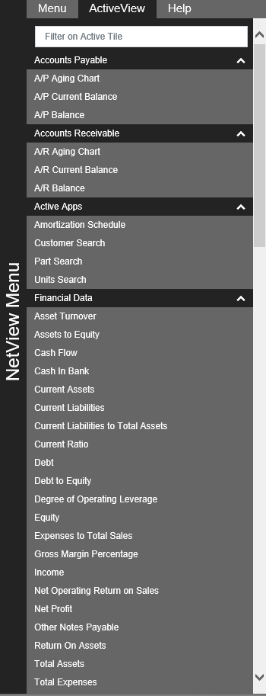

**Filter on ActiveTile:** If you know the name of the tile you wish to use, you can quickly locate it by entering all or part of the name in this field at the top of the menu. Hit the “Enter” key, and the menu will automatically filter to display only matching tile names. To clear the filter, delete the characters in the field and hit the “Enter” key again. This will restore the full menu. **NOTE:** Much like the Applications tab, the ActiveView tab is divided into submenus. Hiding a submenu you are not using shortens the length of the menu and helps you better locate the tiles you want to use.

**Creating an ActiveTile:** To create a new tile:

* Find the tile’s name on the menu.
* Click on the name and hold down the left mouse button while dragging the cursor over the desktop to the location where you want the tile to appear.
* Release the mouse button to put the tile on the desktop.

**NOTE:** The tiles can be resized as desired and repositioned at any time.

**NOTE:** You can place more than one version of a tile on a desktop. This is particularly helpful if you need to view the same data set for two different locations at the same time (provided the feature is available for that tile); you just add the tile twice and set each tile to have a different location.

**Removing a Tile:** To remove a tile from the desktop, click the “x” in the upper right-hand corner of the tile. The following window will appear:

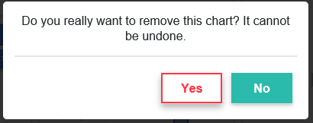

* Click **Yes** to remove the tile from the desktop.
* Click **No** to leave the tile.

**NOTE:** Despite the message, you can always manually re-add the tile to your desktop. This process merely removes that single tile; it does not prevent you from ever placing the tile on your desktop again.

**Common Tile Features:** Many of the tiles have features in common that let you modify the tile’s display. Most of them appear in the tile’s **Settings**  screen. Below is the full list of common features that appear in at least two or more tiles in the same format. Any unique features or customized versions of the common features will be detailed under the section for the tile that features them.

Refresh: This feature’s icon looks like  and appears on the tile’s header. Clicking it refreshes the tile and updates the data set.

Location: This field appears in a tile’s **Settings** screen and allows you to change what dealer location’s data displays on the main tile. The field defaults to the currently selected location and looks like this:



Chart Type: If the ActiveTile displays a chart, this field will appear in the tile’s **Settings** screen. It allows you to select what type of chart you want to use to view the data, and looks like this:



The default type and listed options vary depending on the ActiveTile. The following is a list of all available standard chart type options:

* Column (**always available**)
* Line (**always available**)
* Bar (**always available**)
* Pie
* Donut

Range & Date Selections: If the ActiveTile’s data set relates to time, one or more of these three fields will likely appear in the tile’s **Settings** screen. They allow you to, respectively, select a range of time for the tile to cover, and set the range’s beginning and ending dates/times. They appear as follows:

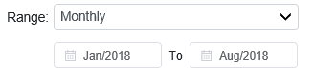

Again, these fields do not always appear together, as some tiles have pre-set range types and only allow you to set the dates. Range type defaults and options also can change depending on the tile, though here is a list of all available standard range options:

* Monthly
* Weekly
* Yearly
* Daily

A variation of this field appears for the G/L Year-over-Year tiles, which compare data from two years:



Use the fields to select the years you want to compare. They will always default to “Current Year” and “Prior Year,” respectively.

Top: For some tiles that display information in lists, this field will appear in the **Settings** screen. It allows you to designate how many items you want to view at once, and looks like this:



All of these fields default to “25,” meaning the top 25 results on the list. The other options also remain the same for all tiles containing the field:

* 50 (view top 50)
* 75 (view top 75)
* 100 (view top 100)

Mode: This field is an alternative to the Range fields in that it sets a time period for the tile’s data set. When shown in the **Settings** screen, it looks like this:



The field will always default to “All,” which means it shows all information ever recorded in the system. While the precise wording of the options differs, they remain consistent from tile to tile, and consist of:

* Week to Date/Past Week
* Month to Date/Past Month
* Year to Date/Past Year

Zone: For the three ActiveTiles that display their information as **gages** (Today’s Parts Sales, Today’s Rental Revenue, Today’s Units Sales), the **Settings** screen contains four “Zone” fields:

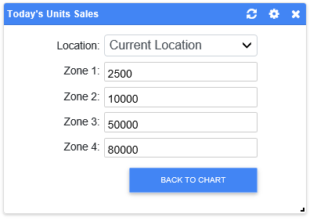

These fields allow you to set the maximum dollar amount for each colored “zone” on the gage, going from the lowest maximum (Zone 1) to the maximum for the whole gage (Zone 4). For example, a gage with the settings above would look like this:

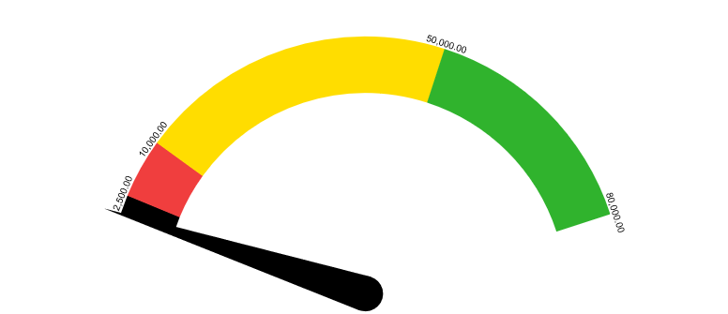

As the Zone 1 field is set to $2,500.00, the gage changes colors from black to red once sales reach that amount. The color changes again from red to yellow once sales reach the Zone 2 amount, $10,000, and so on.

**Tile Descriptions:** Below is the complete list of all currently available tiles, what data they present, where the data comes from, and an explanation of any calculations involved in finding the data. They are presented in the same order as they are on the menu, and divided into the same sections.

**NOTE:** The store location for the data is shown at the bottom of the tile, generally in the lower left-hand corner. If you change the location for the tile, this label will change to match. The data source is always location-specific unless dealing with a consolidated location.

Accounts Payable: These tiles present data drawn from the Accounts Payable (A/P) package of programs.

**A/P Aging Chart:**

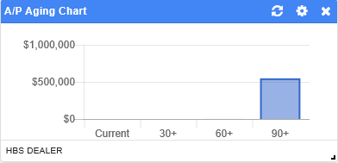

* **Data Set:** Current aging of A/P invoices.
* **Data Source:** A/P Aging Report.

**A/P Current Balance:**

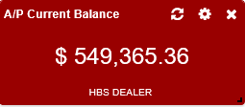

* **Data Set:** Current A/P balance.
* **Data Source:** A/P Aging Report.

**A/P Balance:**

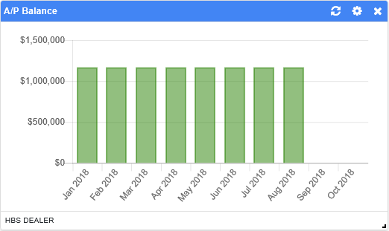

* **Data Set:** A/P balance over time.
* **Data Source:** A/P Aging Report.

Accounts Receivable: These tiles present data drawn from the Accounts Receivable (A/R) package of programs.

**A/R Aging Chart:**

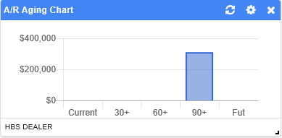

* **Data Set:** Current aging of A/R invoices.
* **Data Source:** A/R Aging Report.

**A/R Current Balance:**

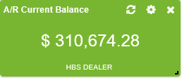

* **Data Set:** Current A/R balance.
* **Data Source:** A/R Aging Report.

**A/R Balance:**

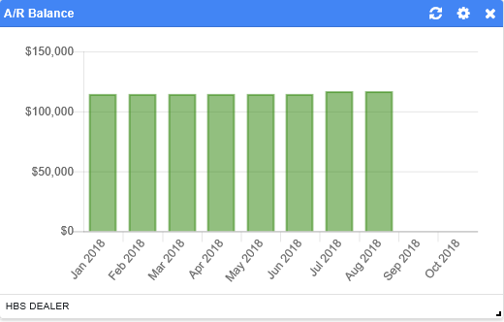

* **Data Set:** A/R balance over time.
* **Data Source:** A/R Aging Report.

Active Apps: These tiles are interactive applications, where you as the user input data into them and they return data based on your entry.

**Amortization Schedule:**

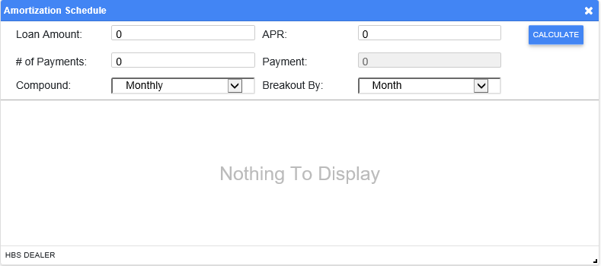

* **Data Set:** Calculate an amortization schedule for loan payments.
* **Data Source:** N/A
* **Features:**
  + **Loan Amount:** Enter the loan amount here.
  + **APR:** Enter the APR here.
  + **# of Payments:** Enter the number of payments here.
  + **Payment:** This represents the amount of each payment, which the application will calculate for you.
  + **Compound:** Select whether the compound the loan monthly or semi-annually.
  + **Breakout By:** Select whether to show the breakout by month or year.
  + **Calculate:** Click this button to calculate the schedule, which will display below the fields.

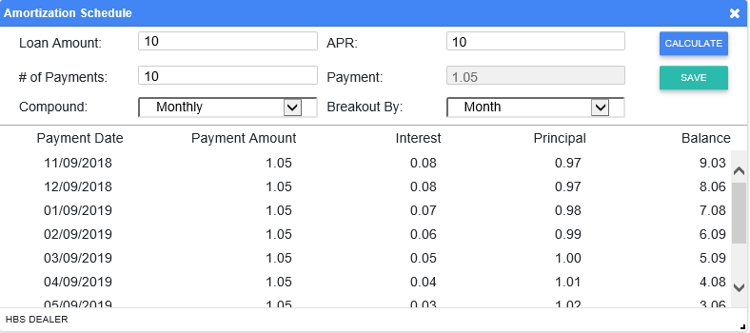

* + **Save:** Click this button to generate a PDF of the schedule.

**Customer Search:**

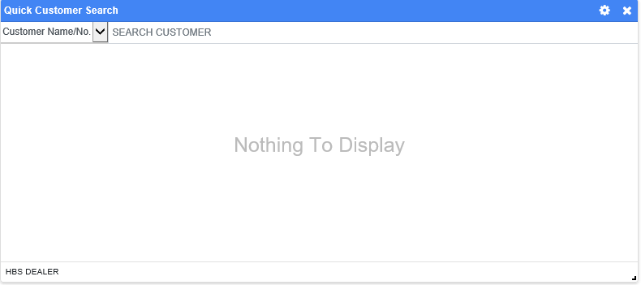

* **Data Set:** Make a customer search from the desktop.
* **Data Source:** Results pulled from A/R customer files.
* **Features:**
  + **Search Type:** Set what type of customer information you want to search for. The options are:
    - Customer Name/No. (**default**)
    - Zip/Postal Code
    - Territory
    - City
    - Telephone
    - Area Code
  + **Search Customer:** Depending on the search type selected, enter all or part of the search criteria here. Hit the “Enter” key to trigger the search and view your results.

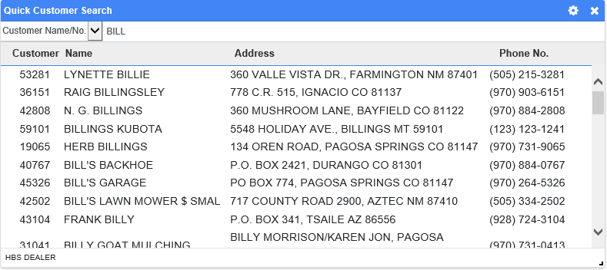

Click on any customer entry to view that customer’s page in NetView Insight (see the “**NetView Insight Detail**” topic page for more information).

**Kubota Invoice Download:**

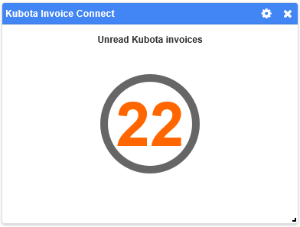

* **Data Set:** Shows the number of invoices downloaded from Kubota that the user has not read. **NOTE:** If there was an error in the invoice download, a message will appear on the main tile informing you of the problem.
* **Data Source:** All downloaded Kubota invoices.
* **Features:**
  + **Settings:**

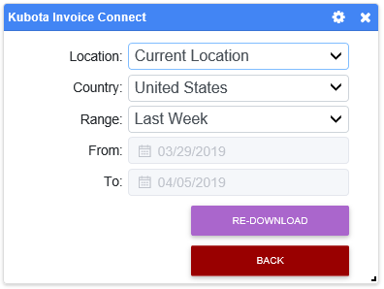

* **Country:** Set whether your dealership is located in the United States or in Canada (currently only US is supported).
* **Range:** Choose a new date range to see all unread invoices that fall within that time period. Range options are:
  + Last Week (default)
  + Last Viewed
  + Last Day
  + Last Month
  + Custom (use the **From/To** fields to set a custom date range)
* **Re-Download:** Click this button to re-download your invoices from Kubota in case of a download error. If the error indicator then disappears, then all your invoices have successfully downloaded.
* **Back:** Click this button to return to the main tile.
  + **Kubota View Invoice:** Click on the number display in the tile to view a list of all invoices downloaded since the particular user last opened the modal. The modal allows you to view individual invoices as PDFs and print out one or more invoices.

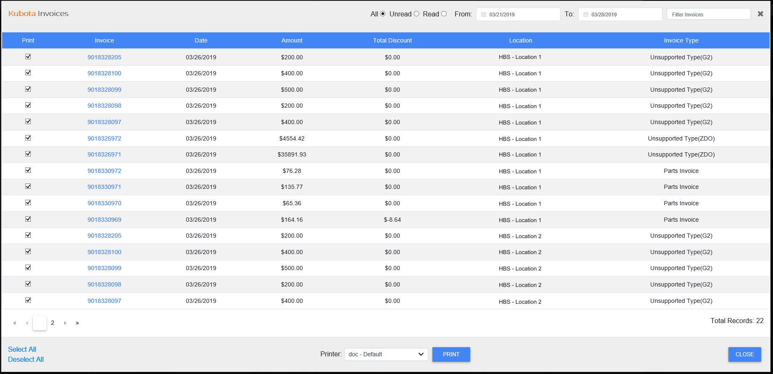

* + - **Columns:** The display grid organizes the data into the following columns:
      * **Print:** Check the box in this column to include the invoice in your print run (you can print more than one invoice using this method).
      * **Invoice:** Shows the invoice number. View the invoice as a PDF by clicking on the number.
      * **Date:** Shows the invoice date.
      * **Amount:** Shows the invoice amount.
      * **Total Discount:** Shows the invoice’s total discount amount.
      * **Location:** Shows the dealer location the invoice applies to.
      * **Invoice Type:** Shows the invoice type.
    - **Select All/Deselect All:** Use these options under the “Print” column to select or deselect all invoices for printing.
    - **Unread/Read Filter:** Use this filter at the top of the window to only view invoices that you’ve read or haven’t read (or all invoices regardless of status).
    - **Date Range Filter:** Use this filter to view only invoices that fall within a specific date range. If you haven’t looked at your invoices for over 30 days, you will have to use this filter to view invoices beyond the past 30 days (as the default display’s maximum date range is 30 days prior to the current date). **NOTE:** If you enter any date range that falls outside the past 6 months, the filter will not work properly.
    - **Filter Invoices:** Use this filter to narrow down the displayed invoices by entering specific criteria, like a particular date or a certain dealer location.
    - **Print:** Set a printer and click this button to print all invoices currently selected for a print run.
    - **Close:** Click this to close the window and return to the main Desktop screen.

**Kubota Warranty Lookup:**

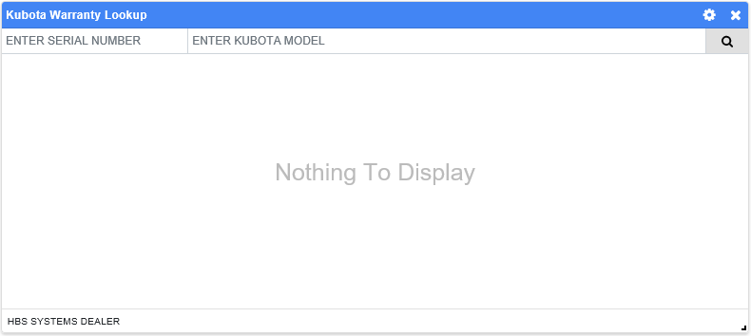

* **Data Set:** Make a Kubota warranty search from the Desktop. **NOTE:** This tile is a Desktop version of the **Kubota Warranty Lookup (KUBL)** program and provides the same search function.
* **Data Source:** Kubota warranty information sent from the manufacturer.
* **Features:**
  + **Enter Serial Number:** Enter the serial number of the Kubota equipment here.
  + **Enter Kubota Model:** Enter the equipment’s full or partial Kubota model number here.
  + **Search:** Click this button to generate your results. Note that if you enter a **partial** model number, you will likely get multiple results.

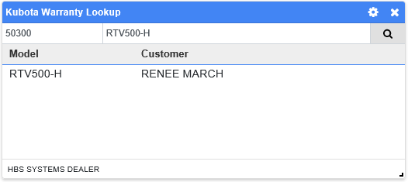

* + **View Warranty Info:** Click on an entry to view its Warranty Information.

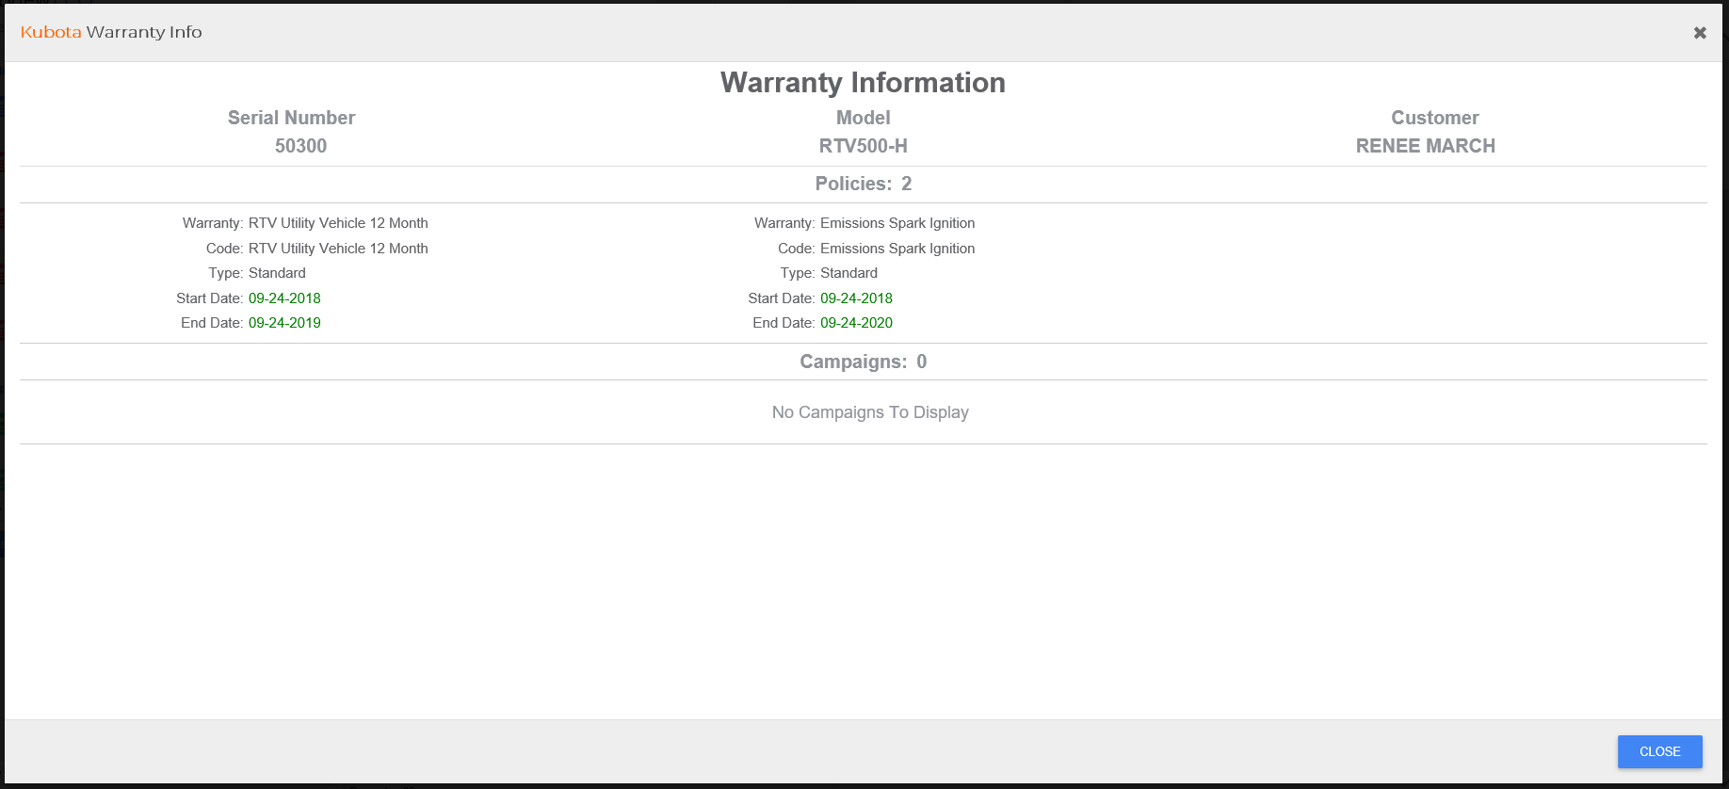

**Part Search:**

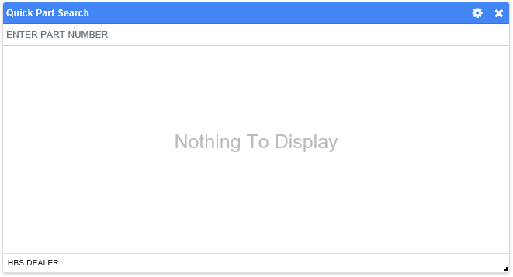

* **Data Set:** Make a parts search from the desktop.
* **Data Source:** Results pulled from all parts information records.
* **Features:**
  + **Enter Part Number:** Enter all or part of the part number you want to search for. The results will display as follows:

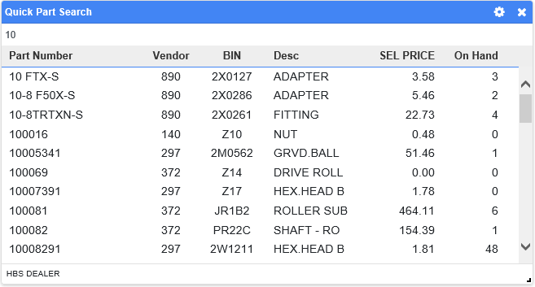

Click on the part entry to view the part’s page in **Part Inquiry (PI)**.

**Units Search:**

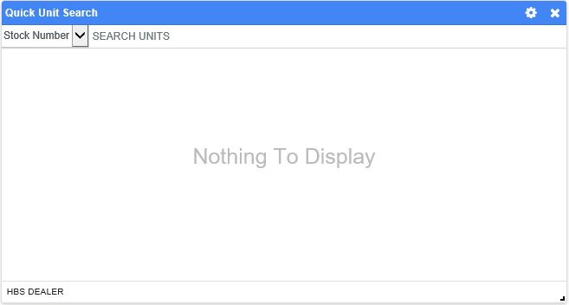

* **Data Set:** Make a unit search from the desktop.
* **Data Source:** Results pulled from all units information records.
* **Features:**
  + **Search Type:** Set what type of unit information you want to search for. The options are:
    - Stock Number (**default**)
    - Serial Number
    - Model
    - Type
    - Make
  + **Search Units:** Depending on the search type selected, enter all or part of the search criteria here. Hit the “Enter” key to trigger the search and view your results.

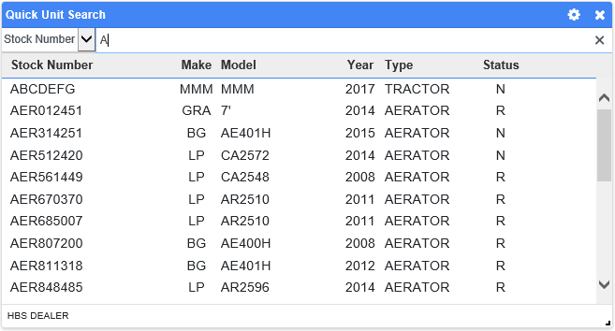

Click on the unit entry to view the unit’s page in **Unit Inquiry (UI)**.

Financial Data: These tiles all concern financial information drawn from across the system rather than any particular package of programs.

**Asset Turnover:**

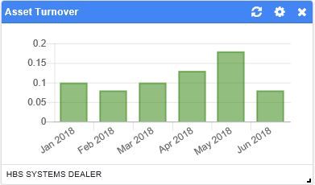

* **Data Set:** Ratio over time of sales to current assets.
* **Data Source:** General Ledger accounts with account type codes “S” and “A.”
* **Calculation:** Asset Turnover Ratio=Sales (/) Current Assets
  + Sales=S accounts total value
  + Assets=A accounts total value

**Assets to Equity:**

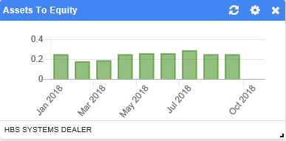

* **Data Set:** Ratio over time of assets to equity.
* **Data Source:** General Ledger accounts with account type codes “A” and “L.”
* **Calculation:** Ratio=Assets (/) Equity
  + Assets=A accounts total value
  + Equity=L accounts total value

**Cash Flow:**

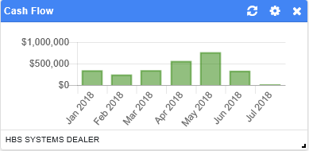

* **Data Set:** Cash flow amount over time.
* **Data Source:** General Ledger accounts with account type codes “S,” “V,” and “W.”
* **Calculation:** Cash Flow Amount=Sales (-) Expenses
  + Sales=S accounts total value
  + Expenses=V accounts total value (+) W accounts total value

**Cash In Bank:**

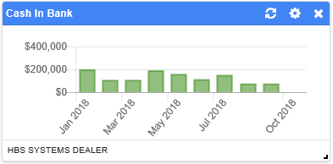

* **Data Set:** Cash in Bank amount over time.
* **Data Source:** General Ledger accounts with the account type code “A1” (Cash in Bank=A1 account(s) value).

**Current Assets:**

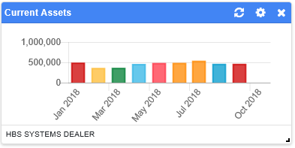

* **Data Set:** Value of current assets over time.
* **Data Source:** General Ledger accounts with account type code “A” (Assets=A accounts total value).

**Current Liabilities:**

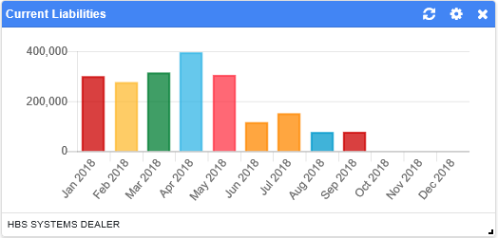

* **Data Set:** Value of current liabilities over time.
* **Data Source:** General Ledger accounts with account type codes “G” and “I” (Current Liabilities= G accounts total value (+) I accounts total value).

**Current Liabilities to Total Assets:**

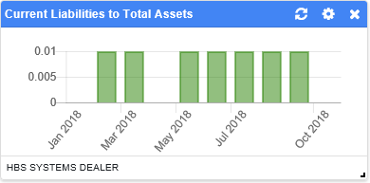

* **Data Set:** Ratio over time of current liabilities to total assets.
* **Data Source:** General Ledger accounts with account type codes “I” and “A.”
* **Calculation:** Ratio=Current Liabilities (/) Total Assets.
  + Current Liabilities=I accounts total value
  + Total Assets=A accounts total value

**Current Ratio:**

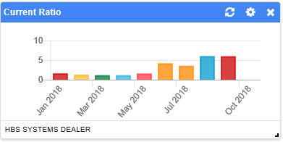

* **Data Set:** Ratio over time of current assets to liabilities.
* **Data Source:** General Ledger accounts with account type codes “A,” “G,” and “I.”
* **Calculation:** Current Ratio=Current Assets (/) Liabilities
  + Current Assets=A accounts total value
  + Liabilities=G accounts total value (+) I accounts total value

**Debt:**

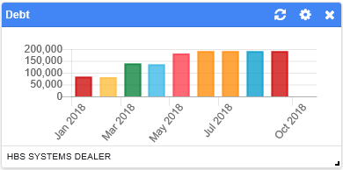

* **Data Set:** Debt amount over time.
* **Data Source:** General Ledger accounts with account type code “J” (Debt=J accounts total value).

**Debt To Equity:**

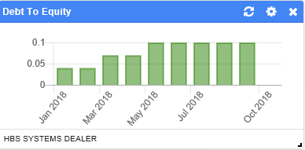

* **Data Set:** Ratio over time of debt to equity.
* **Data Source:** General Ledger accounts with account type codes “J” and “L.”
* **Calculation:** Ratio=Debt (/) Equity
  + Debt=J accounts total value
  + Equity=L accounts total value

**Degree of Operating Leverage:**

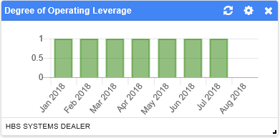

* **Data Set:** Degree of operating leverage over time.
* **Data Source:** General Ledger accounts with the account type codes “S,” “T,” “V,” “Y,” “Z,” and “W.”
* **Calculation:** Degree of Operating Leverage=X (/) (X (+) W accounts total value)
  + X=S accounts total value (+) T accounts total value (+) V accounts total value (+) Y accounts total value (+) Z accounts total value

**Equity:**

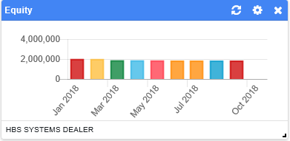

* **Data Set:** Equity amount over time.
* **Data Source:** General Ledger accounts with account type code “L” (Equity=L accounts total value).

**Expenses to Total Sales:**

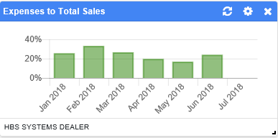

* **Data Set:** Ratio over time of expenses to total sales.
* **Data Source:** General Ledger accounts with account type codes “W,” “V,” and “S.”
* **Calculation:** Ratio=Expenses (/) Total Sales
  + Expenses=W accounts total value (+) V accounts total value.
  + Total Sales=S accounts total value

**Gross Margin Percentage:**

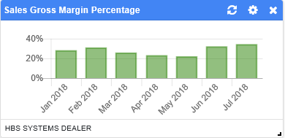

* **Data Set:** Gross margin percentage over time.
* **Data Source:** General Ledger accounts with account type codes “S” and “T.”
* **Calculation:** Gross Margin Percentage=100 (x) ((Sales Revenue (-) Sales Cost) (/) Sales Revenue)
  + Sales Revenue=S accounts total value
  + Sales Cost=T accounts total value

**Income:**

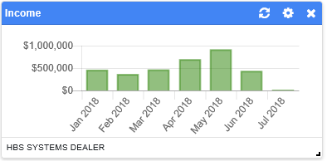

* **Data Set:** Income amount over time.
* **Data Source:** General Ledger accounts with account type codes “S” and “Y” (Income=S accounts total value (+) Y accounts total value).

**Net Operating Return on Sales:**

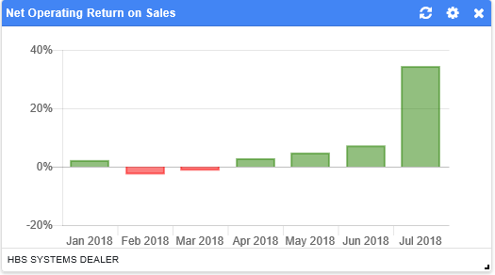

* **Data Set:** Percentage of net operating return on sales over time.
* **Data Source:** General Ledger accounts with the account type codes “S,” “Y,” “T,” “W,” and “V.”
* **Calculation:** Net Operating Return On Sales Percentage=100 (x) (Net Profit (/) Sales)
  + Net Profit=(S accounts total value (+) Y accounts total value) (-) (T accounts total value (+) W accounts total value (+) V accounts total value)
  + Sales=S accounts total value

**Net Profit:**

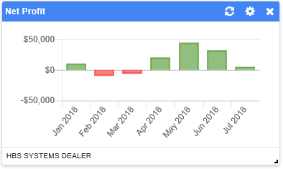

* **Data Set:** Net profit amount over time.
* **Data Source:** General Ledger accounts with the account type codes “S,” “Y,” “T,” “W,” and “V.”
* **Calculation:** Net Profit=(S accounts total value (+) Y accounts total value) (-) (T accounts total value (+) W accounts total value (+) V accounts total value)

**Other Notes Payable:**

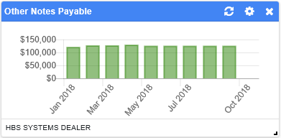

* **Data Set:** Notes Payable Other amount over time.
* **Data Source:** General Ledger accounts with account type code “H.”
* **Calculation:** Notes Payable Other Amount=H accounts total value (-) (H1 account(s) value (+) H3 account(s) value)

**Return on Assets:**

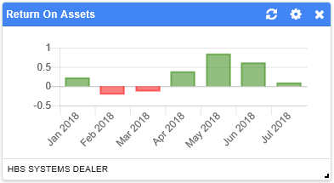

* **Data Set:** Ratio over time of net profit to assets.
* **Data Source:** General Ledger accounts with the account type codes “S,” “Y,” “W,” “V,” “T,” and “A.”
* **Calculation:** Return on Assets=Net Profit (/)Assets
  + Net Profit=(S accounts total value (+) Y accounts total value) (-) (T accounts total value (+) W accounts total value (+) V accounts total value)
  + Assets=A accounts total value

**Total Assets:**

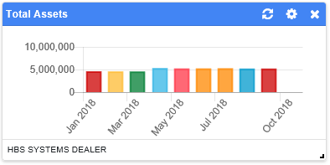

* **Data Set:** Total assets value over time.
* **Data Source:** General Ledger accounts with account type codes “A,” “B,” “C,” “D,” “E,” and “F.”
* **Calculation:** Total Assets=A accounts total value (+) B accounts total value (+) C accounts total value (+) D accounts total value (+) E accounts total value (+) F accounts total value

**Total Expenses:**

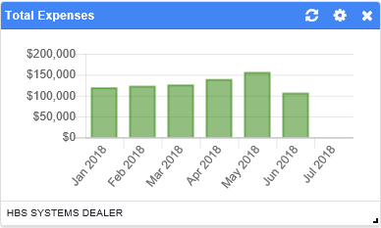

* **Data Set:** Amount of total expenses over time.
* **Data Source:** General Ledger accounts with account type codes “W” and “V.”
* **Calculation:** Total Expenses=W accounts total value (+) V accounts total value

**Total Sales Amount:**

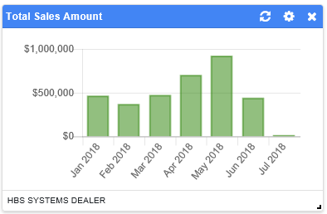

* **Data Set:** Total sales amount over time.
* **Data Source:** General Ledger accounts with account type code “S” (Total Sales=S accounts total value).

**Total Sales Margin:**

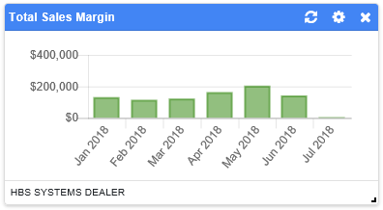

* **Data Set:** Total sales margin amount over time.
* **Data Source:** General Ledger accounts with account type codes “S” and “T.”
* **Calculation:** Total Sales Margin=S accounts total value (-) T accounts total value

**Working Capital:**

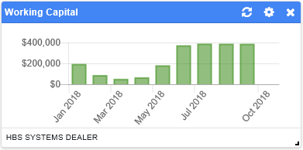

* **Data Set:** Working capital amount over time.
* **Data Source:** General Ledger accounts with account type codes “A,” “G,” and “I.”
* **Calculation:** Working Capital=Current Assets (-) Current Liabilities
  + Current Assets=A accounts total value
  + Current Liabilities=G accounts total value (+) I accounts total value

**Working Capital Turnover:**

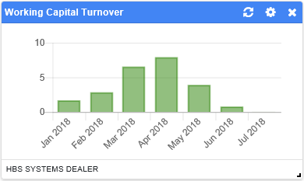

* **Data Set:** Ratio over time of net sales over working capital.
* **Data Source:** General Ledger accounts with the account type codes “T,” “A,” “G,” and “I.”
* **Calculation:** Working Capital Turnover=Net Sales (/) Working Capital
  + Net Sales=T accounts total value
  + Working Capital=A accounts total value (-) (G accounts total value (+) I accounts total value)

General Ledger: These tiles present data drawn from the General Ledger (G/L) package of programs.

**G/L DOC Report:**

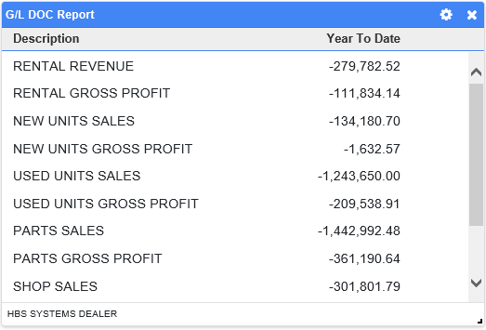

* **Data Set:** Year-to-date dollar activity for selected areas of interest set up for the Daily Operating Control (DOC) Report.
* **Data Source:** DOC Report.

**G/L DOC Report Balance:**

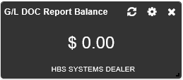

* **Data Set:** Current balance of the Daily Operating Control (DOC) Report.
* **Data Source:** DOC Report.
* **Features:**

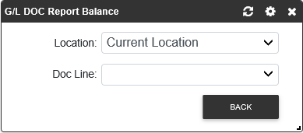

* + - **Doc Line:** Select the line of the report whose balance you want to view. The selection will depend on how your DOC report is set up.

**G/L Year-over-Year Expense Chart:**

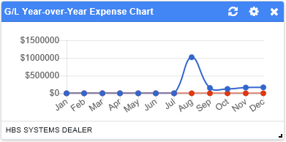

* **Data Set:** Expenses per month for two different calendar years side-by-side.
* **Data Source:** All General Ledger accounts.

**G/L Year-over-Year Profit Chart:**

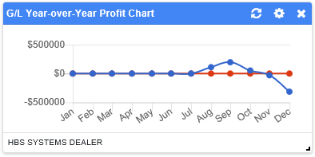

* **Data Set:** Profits per month for two different calendar years side-by-side.
* **Data Source:** All General Ledger accounts.

**G/L Year-over-Year Sales Chart:**

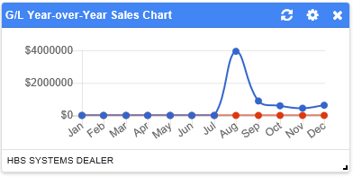

* **Data Set:** Sales per month for two different calendar years side-by-side.
* **Data Source:** All General Ledger accounts.

Parts: These tiles present data drawn from the Parts package of programs.

**Open Parts Picking Ticket List:**

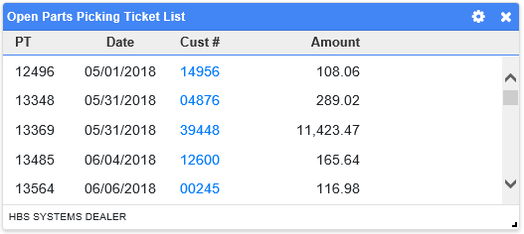

* **Data Set:** List of open picking tickets. **NOTE:** Click on the blue customer number to view the customer’s NetView Insight page (see the “**NetView Insight Detail**” topic page for more information).
* **Data Source:** All recorded picking tickets.

**Parts Absorption Factor:**

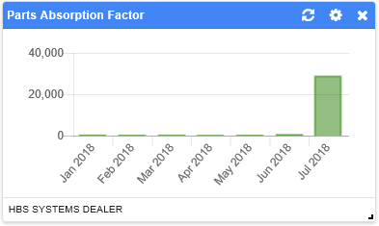

* **Data Set:** Parts absorption factor over time.
* **Data Source:** General Ledger accounts with account type codes “SE,” “V1,” “V9,” “W1,” “W9,” and “Y.”
* **Calculation:** Parts Absorption Factor=SE account(s) value (/) ((V1 account(s) value (+) V9 account(s) value (+) W1 account(s) value (+) W9 account(s) value) (-) Y accounts total value).

**Parts Bin Trips:**

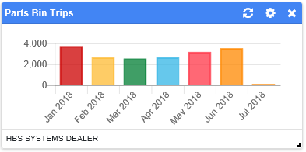

* **Data Set:** Number of bin trips made over time.
* **Data Source:** All recorded bin trips.

**Parts Contribution to Total Sales:**

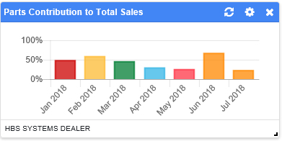

* **Data Set:** Percentage over time of how much parts sales contribute to total sales.
* **Data Source:** General Ledger accounts with account type code “S.”
* **Calculation:** Percentage=100 (x) (Parts Sales (/) Total Sales)
  + Parts Sales=SE account(s) value
  + Total Sales=S accounts total value

**Parts Cost Trend:**

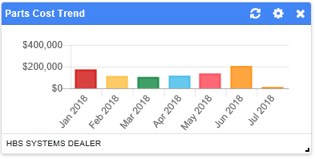

* **Data Set:** Parts cost value over time.
* **Data Source:** Inventory Month End records

**Parts Gross Margin Percentage:**

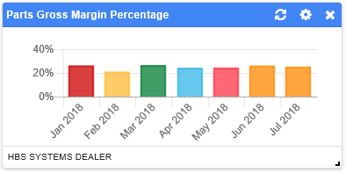

* **Data Set:** Parts gross margin percentage over time.
* **Data Source:** General Ledger accounts with account types “SE” and “TE.”
* **Calculation:** Parts Gross Margin Percentage=100 (x) ((Parts Sales Revenue (-) Parts Sales Cost) (/) Parts Sales Revenue)
  + Parts Sales Revenue=SE account(s) value
  + Parts Sales Cost=TE account(s) value

**G/L Parts Inventory:**

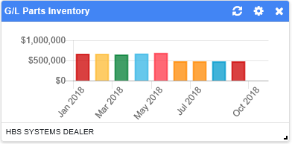

* **Data Set:** Value of parts inventory over time as recorded in the General Ledger.
* **Data Source:** General Ledger accounts with account type code “B5” (Parts Inventory Value=B5 account(s) value).

**Parts Inventory Value:**

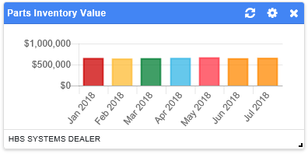

* **Data Set:** Value of part inventory over time as taken from the Inventory Month End records.
* **Data Source:** Inventory Month End records.

**Parts Margin Trend:**

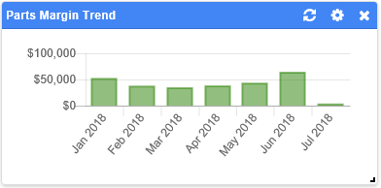

* **Data Set:** Parts margin value over time.
* **Data Source:** Inventory Month End records.

**Parts Order Efficiency:**

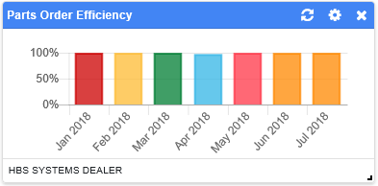

* **Data Set:** Part order efficiency percentage over time.
* **Data Source:** All orders recorded in the system.
* **Calculation:** Part Order Efficiency Percentage=100 (x) (Total Stock Orders (/) (Total Stock Orders (+) Total Orders)).

**Parts Price Changes:**

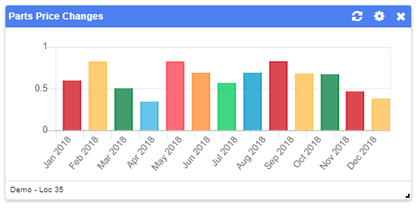

* **Data Set:** Price change value for parts inventory over time.
* **Data Source:** Inventory Month End records.

**Parts Price File List:**

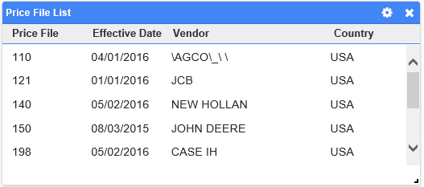

* **Data Set:** List of parts price files.
* **Data Source:** Parts price files.

**Parts Returns:**

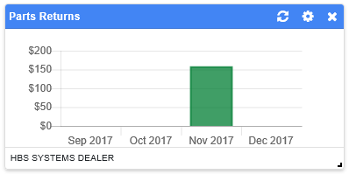

* **Data Set:** Parts returns amount over time.
* **Data Source:** Inventory Month End records.

**Parts Sales Amount:**

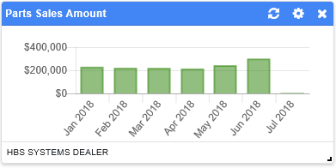

* **Data Set:** Total parts sales amount over time. **NOTE:** Should be identical to data for same parameters in **Parts Sales Trend** ActiveTile.
* **Data Source:** General Ledger accounts with account type code “SE” (Parts Sales=SE account(s) value).

**Parts Sales Margin:**

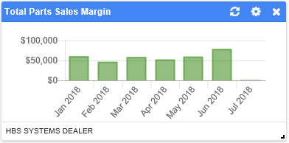

* **Data Set:** Total parts sales margin amount over time.
* **Data Source:** General Ledger accounts with account type code “SE” and “TE.”
* **Calculation:** Parts Sales Margin=Parts Sales (-) Parts Costs.
  + Parts Sales=SE account(s) value.
  + Parts Cost=TE account(s) value.

**Parts Sales Trend:**

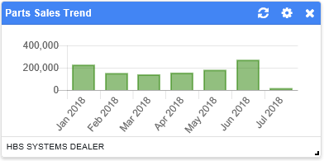

* **Data Set:** Parts sales value over time. **NOTE:** Should be identical to data for same parameters in **Parts Sales Amount** ActiveTile.
* **Data Source:** General Ledger accounts with account type code “SE” (Parts Sales=SE account(s) value).

**Parts Turn Ratio:**

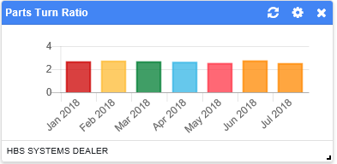

* **Data Set:** Turn ratio over time.
* **Data Source:** Inventory Month End records.

**Parts Turnover:**

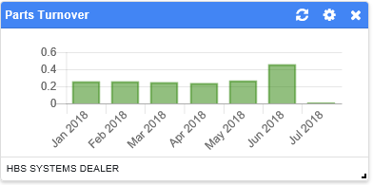

* **Data Set:** Parts Turnover ratio over time.
* **Data Source:** General Ledger accounts with account type codes “TE” and “B5.”
* **Calculation:** Parts Turnover=Parts Sales Costs (/) Parts Inventory Value.
  + Parts Sales Costs=TE account(s) value
  + Parts Inventory Value=B5 account(s) value

**Percentage Parts Margin:**

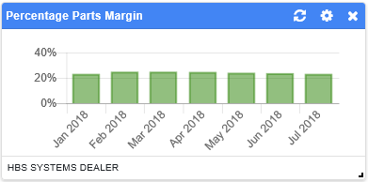

* **Data Set:** Parts margin percentage over time.
* **Data Source:** General Ledger accounts with account type codes “SE” and “TE.”
* **Calculation:** Parts Margin Percentage=100 (x) ((Parts Sales (-) Parts Costs) (/) Parts Sales)
  + Parts Sales=SE account(s) value
  + Parts Costs=TE account(s) value

**Today’s Parts Sales:**

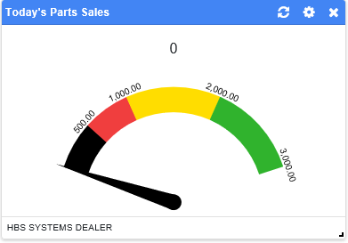

* **Data Set:** Total amount of parts sales made on the current date (continually updates).
* **Data Source:** All Point-of-Sale and Service invoices recorded with the current date.

**Total Parts Open Picking Tickets:**

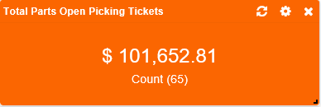

* **Data Set:** Total value and number of open picking tickets.
* **Data Source:** All recorded picking tickets.

Rental: These tiles present data drawn from the Rental package of programs.

**Today’s Rental Revenue:**

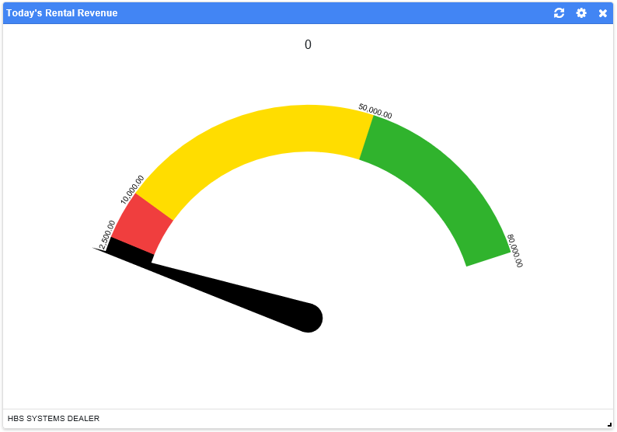

* **Data Set:** Total amount of rental revenue made on the current date (continually updates).
* **Data Source:** All Rental invoices recorded with the current date.

**Total Open Rental Contracts:**

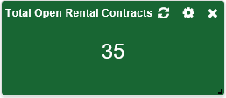

* **Data Set:** Total number of open contracts.
* **Data Source:** All recorded Rental contracts.

**Stale Rental Inventory:**

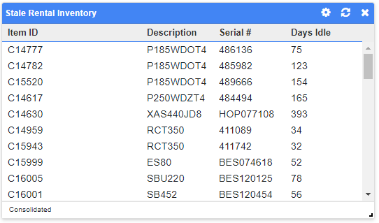

* **Data Set:** List of units that have had no rentals within a set time period.
* **Data Source:** The Stale Inventory Report in Rental Reports (RR).
* **Features:**

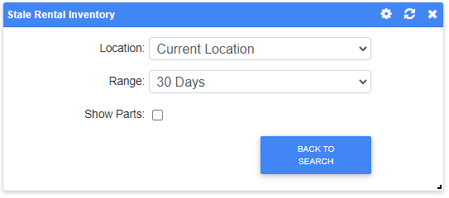

* + **Range:** Set the time frame during which a unit must have no rentals in order to be included in this list.
    - 30 Days (**default**)
    - 60 Days
    - 90 Days
  + **Show Parts:** Check this box to include **non-serialized** rental units with no rentals during the selected time period on the list. Leave it unchecked (**default**) to only have the list show **serialized** units.

Service: These tiles present data drawn from the Service package of programs.

**Service Absorption Factor:**

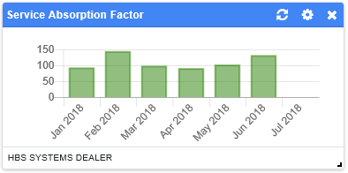

* **Data Set:** Service absorption factor over time.
* **Data Source:** General Ledger accounts with the account type codes “SG,” “V1,” “V9,” “W1,” “W9,” and “Y.”
* **Calculation:** Service Absorption Factor=SG account(s) value (/) ((V1 account(s) value (+) V9 account(s) value (+) W1 account(s) value (+) W9 account(s) value) (-) Y accounts total value)

**Service Contribution to Total Sales:**

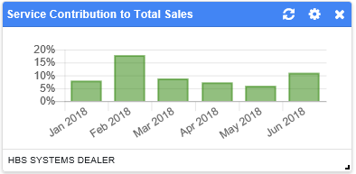

* **Data Set:** Percentage over time of how much service sales contribute to total sales.
* **Data Source:** General Ledger accounts with account type code “S.”
* **Calculation:** Percentage=100 (x) (Service Sales (/) Total Sales)
  + Service Sales=SG account(s) value
  + Total Sales=S accounts total value

**Service Estimate List:**

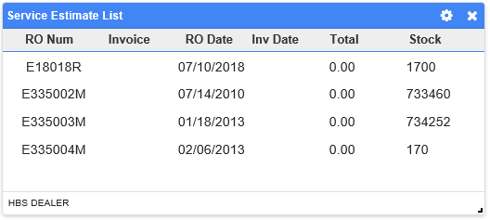

* **Data Set:** List of current service estimates by RO number.
* **Data Source:** All Repair Orders with recorded estimates.

**Service Gross Margin Percentage:**

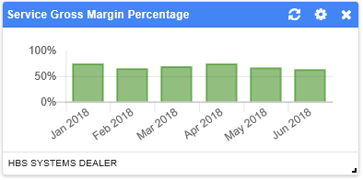

* **Data Set:** Service gross margin percentage over time.
* **Data Source:** General Ledger accounts with account type codes “SG” and “TG.”
* **Calculation:** Service Gross Margin Percentage=100 (x) ((Service Sales Revenue (-) Service Sales Costs) (/) Service Sales Revenue)
  + Service Sales Revenue=SG account(s) value
  + Service Sales Cost=TG account(s) value

**Service Invoices Value:**

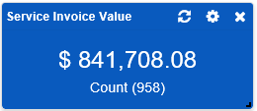

* **Data Set:** Total dollar value and number of current service invoices.
* **Data Source:** All recorded Service invoices.

**Service Most Repaired List:**

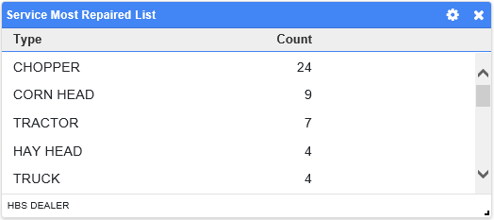

* **Data Set:** List of most repaired unit types.
* **Data Source:** All recorded Repair Orders.

**Service Order List:**

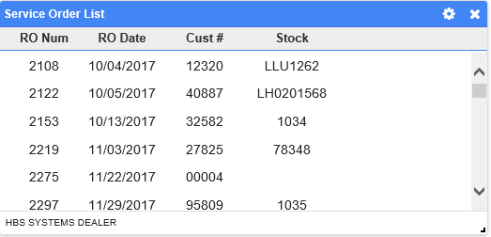

* **Data Set:** List of current service orders by RO number.
* **Data Source:** All recorded Repair Orders.

**Service Sales Amount:**

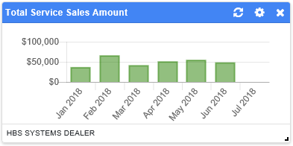

* **Data Set:** Total service sales amount over time.
* **Data Source:** General Ledger accounts with account type code “SG” (Service Sales=SG account(s) value).

**Service Sales Margin:**

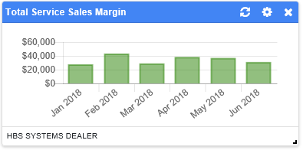

* **Data Set:** Total service sales margin amount over time.
* **Data Source:** General Ledger accounts with account type codes “SG” and “TG.”
* **Calculation:** Service Sales Margin=Service Sales Revenue (-) Service Sales Cost
  + Service Sales Revenue=SG account(s) value
  + Service Sales Cost=TG account(s) value

**Service WIP Chart:**

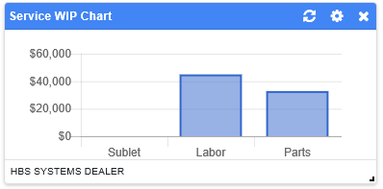

* **Data Set:** Total dollar amounts of all repair orders in progress, grouped by allocation: sublet, labor, and/or parts.
* **Data Source:** All recorded Repair Orders.

**Top Service Customers:**

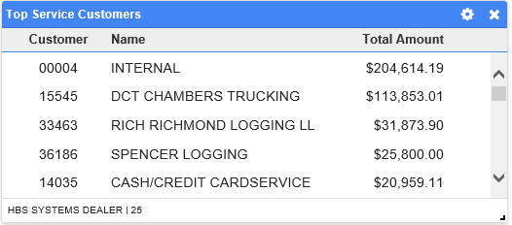

* **Data Set:** List of top service customers by amount spent.
* **Data Source:** All recorded Service invoices.

Units: These tiles present data drawn from the Units package of programs.

**Most Profitable Units By $:**

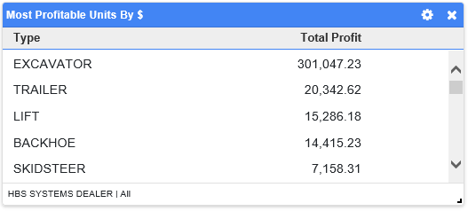

* **Data Set:** List of most profitable unit types by dollar amount and total profit from each type.
* **Data Source:** All Unit information records.

**Most Profitable Units By Margin:**

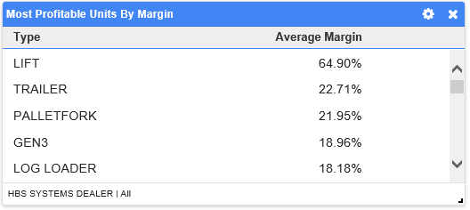

* **Data Set:** List of most profitable unit types by margin and the average margin for each type.
* **Data Source:** All Unit information records.

**Most Recent Units Sales:**

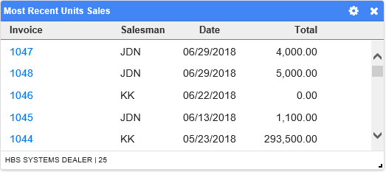

* **Data Set:** List of recent unit sales. **NOTE:** Select the blue invoice number to open a PDF of the invoice in a new window.
* **Data Source:** 100 most recently recorded Units invoices.

**Most Revenue Generating Units:**

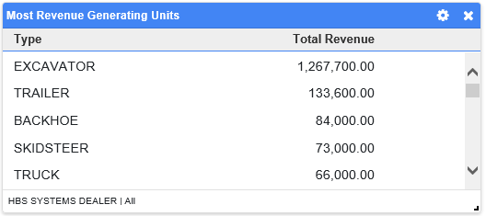

* **Data Set:** List of the unit types that generate the most revenue and the revenue amount for each type.
* **Data Source:** All Unit information records.

**Most Sold Units By Count:**

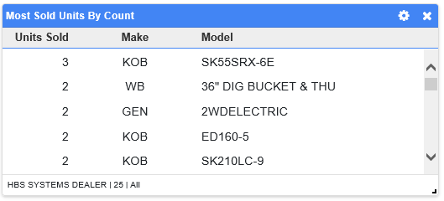

* **Data Set:** List of most sold Unit models by number of sales.
* **Data Source:** All recorded Units invoices.

**New Units Sales Amount:**

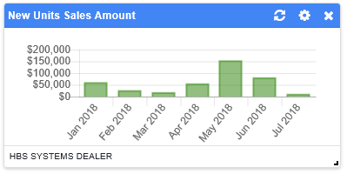

* **Data Set:** New unit sales amount over time.
* **Data Source:** General Ledger accounts with the account type code “SA” (New Unit Sales=SA account(s) value).

**New Units Sales Margin:**

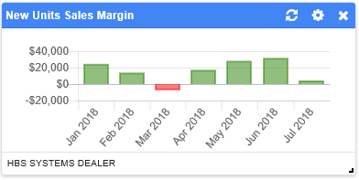

* **Data Set:** Margin amount for new unit sales over time.
* **Data Source:** General Ledger accounts with the account type codes “SA” and “TA.”
* **Calculation:** New Units Sales Margin=New Units Sales Revenue (-) New Units Sales Costs
  + New Units Sales Revenue=SA account(s) total.
  + New Units Sales Costs=TA account(s) total.

**New Units Turnover:**

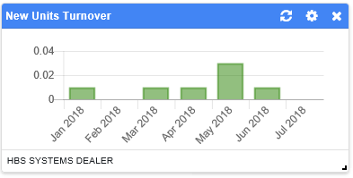

* **Data Set:** New units turnover ratio over time.
* **Data Source:** General Ledger accounts with account type codes “TA” and “B1.”
* **Calculation:** New Units Turnover=New Units Sales Costs (/) New Units Inventory Value
  + New Units Sales Costs=TA account(s) value
  + New Units Inventory Value=B1 account(s) value

**Open Units Quotes:**

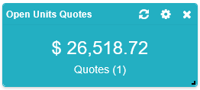

* **Data Set:** Current number and total value of open unit quotes.
* **Data Source:** All recorded Units quotes.

**Open Units Quotes List:**

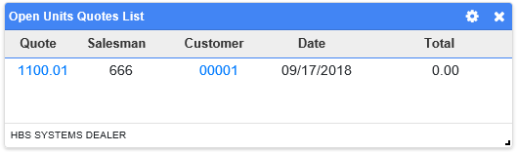

* **Data Set:** List of open unit quotes.
  + Click on the blue quote number to open a PDF of the quote in a new tab.
  + Click on the blue customer number to view the customer’s NetView Insight page (see the “**NetView Insight Detail**” topic page for more information).
* **Data Source:** All recorded Units quotes.

**Sold Units With Payables:**

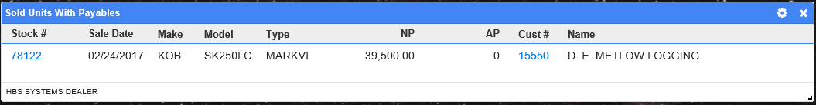

* **Data Set:** List of sold units with either Notes Payable or Accounts Payable amounts.
  + Click on the blue stock number to open the unit’s record in Unit Inquiry (UI).
  + Click on the blue customer number to view the customer’s NetView Insight page (see the “**NetView Insight Detail**” topic page for more information).
* **Data Source:** All Units information records.

**Today’s Units Sales:**

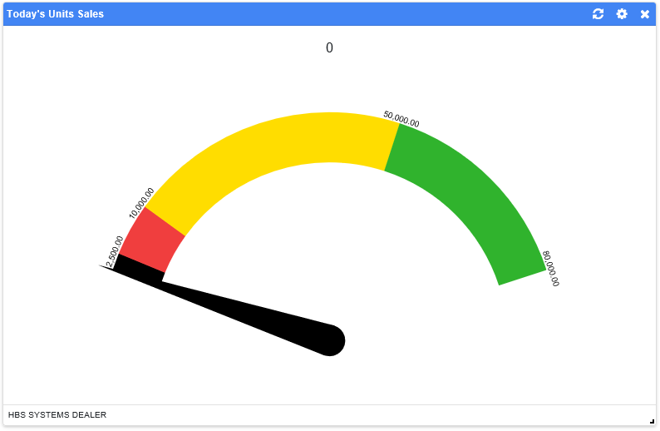

* **Data Set:** Total amount of unit sales made on the current date (continually updates).
* **Data Source:** All Point-of-Sale and Units invoices recorded with the current date.

**Top Stocked Units:**

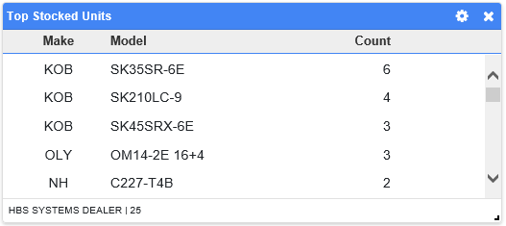

* **Data Set:** List of top stocked units by make and model, as well as the number of each model currently in stock.
* **Data Source:** All Units information records.

**Top Units Salesmen:**

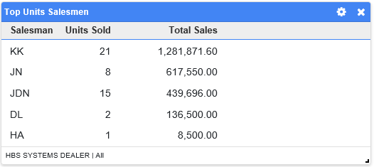

* **Data Set:** List of top units salesmen.
* **Data Source:** All recorded Units invoices.

**Total Units Sales Amount:**

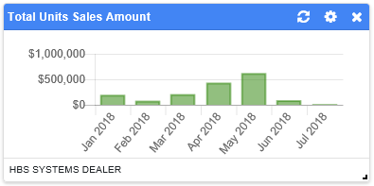

* **Data Set:** Total unit sales amount over time.
* **Data Source:** General Ledger accounts with account type codes “SA” and “SC.”
* **Calculation:** Total Units Sales=SA account(s) value (+) SC account(s) value

**Total Units Sales Margin:**

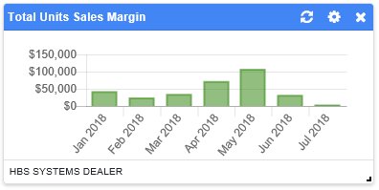

* **Data Set:** Margin amount for total unit sales over time.
* **Data Source:** General Ledger accounts with the account type codes “SA,” “SC,” “TC,” and “TA.”
* **Calculation:** Total Units Sales Margin=Total Units Sales Revenue (-) Total Units Sales Costs
  + Total Units Sales Revenue=SA account(s) value (+) SC account(s) value
  + Total Units Sales Costs=TC account(s) value (+) TA account(s) value

**Total Units Turnover:**

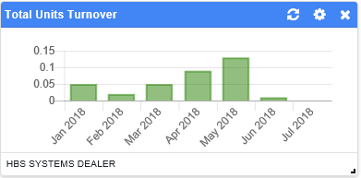

* **Data Set:** Total units turnover ratio over time.
* **Data Source:** General Ledger accounts with the account type codes “TA,” “TC,” “B3,” and “B1.”
* **Calculation:** Total Units Turnover=Total Units Sales Costs (/) Total Units Inventory Value
  + Total Units Sales Costs=TC account(s) value (+) TA account(s) value
  + Total Units Inventory Value=B3 account(s) value (+) B1 account(s) value

**Units By Age:**

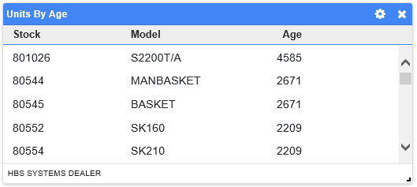

* **Data Set:** List of all new, used, and rental units by age.
* **Data Source:** All Units information records.

**Units Contribution to Total Sales:**

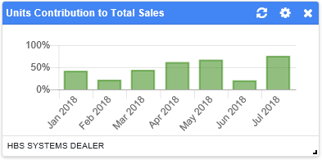

* **Data Set:** Percentage over time of how much unit sales contribute to total sales.
* **Data Source:** General Ledger accounts with account type code “S.”
* **Calculation:** Percentage=100 (x) (Unit Sales (/) Total Sales)
  + Unit Sales=SA account(s) value (+) SC account(s) value
  + Total Sales=S accounts total value

**Units Gross Margin Percentage:**

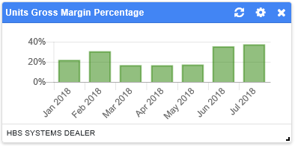

* **Data Set:** Units gross margin percentage over time.
* **Data Source:** General Ledger accounts with the account type codes “SA,” “SC,” “TA” and “TC.”
* **Calculation:** Units Gross Margin Percentage=100 (x) ((Units Sales Revenue (-) Units Sales Costs) (/) Units Sales Revenue)
  + Units Sales Revenue=SA account(s) value (+) SC account(s) value
  + Units Sales Costs=TA account(s) value (+) TC account(s) value

**Units Inventory:**

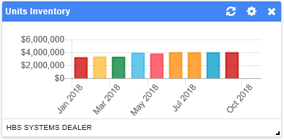

* **Data Set:** Value of unit inventory over time
* **Data Source:** General Ledger accounts with account type codes “B1” and “B3.”
* **Calculation:** Unit Inventory Value=B1 account(s) value (+) B3 account(s) value.

**Units Monthly Sales (Last 5 Years):**

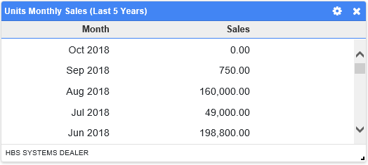

* **Data Set:** List of unit sales value for each month over the last 5 years.
* **Data Source:** All recorded Units invoices from the last 5 years.

**Units Notes Payable:**

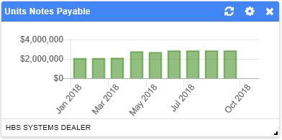

* **Data Set:** Units Notes Payable amount over time.
* **Data Source:** General Ledger accounts with account type codes “H1” and “H3.”
* **Calculation:** Units Notes Payable=H1 account(s) value (+) H3 account(s) value

**Units Sale To Date:**

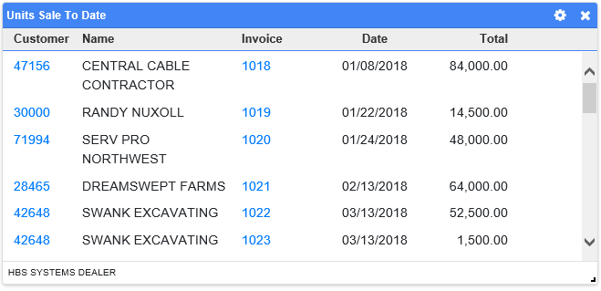

* **Data Set:** List of customers that have recently purchased units, and what units they purchased.
  + Click on the blue customer number to view the customer’s NetView Insight page (see the “**NetView Insight Detail**” topic page for more information).
  + Click on the blue invoice number to open a PDF of the invoice in a new tab.
* **Data Source:** All recorded Units invoices from the past year (maximum time period available).
* **Features:**

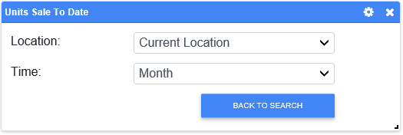

* + - **Time:** Set the time frame during which the customers purchased the units.
      * (Past) Month (**default**)
      * (Past) Year

**Used Units Sales Amount:**

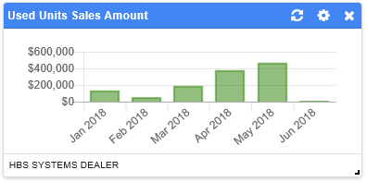

* **Data Set:** Used unit sales amount over time.
* **Data Source:** General Ledger accounts with account type code “SC” (Used Units Sales=SC account(s) value).

**Used Units Sales Margin:**

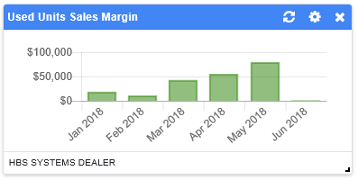

* **Data Set:** Margin amount for used unit sales over time.
* **Data Source:** General Ledger accounts with account type codes “SC” and “TC.”
* **Calculation:** Used Units Sales Margin=Used Units Sales Revenue (-) Used Units Sales Costs
  + Used Units Sales Revenue=SC account(s) value
  + Used Units Sales Costs=TC account(s) value

**Used Units Turnover:**

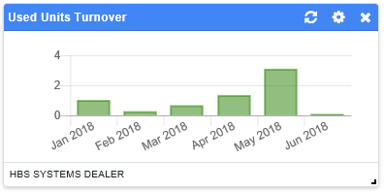

* **Data Set:** Used units turnover ratio over time.
* **Data Source:** General Ledger accounts with the account type codes “B3” and “TC.”
* **Calculation:** Used Units Turnover=Used Units Sales Costs (/) Used Units Inventory Value
  + Used Units Sales Costs=TC account(s) value
  + Used Units Inventory Value=B3 account(s) value

Utilities: These tiles are applications offering additional data sets and functions to better help you run your dealership.

**Weather App:**

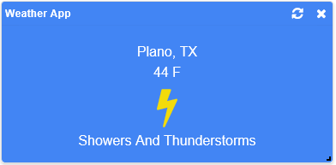

* **Data Set:** Look up the current weather conditions.
* **Data Source:** National Weather Service website.

**Tasks:**

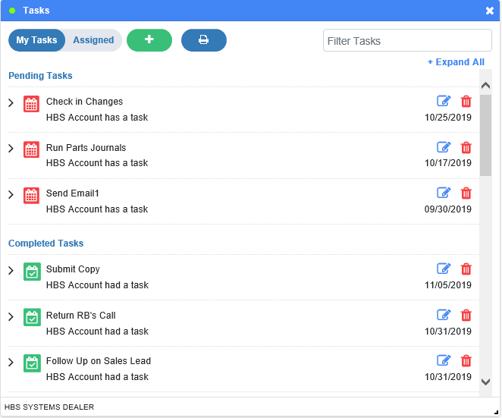

* **Data Set:** View and manage Tasks assigned to and by the current user. Users can assign Tasks to other users and to themselves. **NOTE:** Also available in **NetView Insight**, which will show any Tasks associated with a particular customer.
* **Data Source:** No external source; created and maintained entirely by the ActiveTile.
  + **NOTE:** Communicates with NetView Insight so any changes made in one location will be reflected in the other.
  + **NOTE:** System can generate specific tasks within the tile depending on the user’s permissions within specific programs. **Example:** System will create a task if the user is an **IPO Approver** that needs to review a Pending Approval Requisition (see **Integrated Purchase Orders (IPO)** for more details).
* **Features:**
  + **Task List:** The main tile view is a list of Tasks either assigned to or by the current user, depending on which tab is selected for display.
    - **My Tasks/Assigned:** Switches the tile between the two possible Task list views.
      * **My Tasks:** Shows all Tasks assigned **to** the user.
      * **Assigned:** Shows all Tasks assigned **by** the user.
    - **Task Entry Detail:** Each entry on the list automatically shows the Task’s subject, the user assigned to perform it, and the Task’s due date.
      * **Expanded Entry Detail:** Use the arrow icon to the entry’s left to view the Task’s description, creator, and creation date. You will also be offered the chance to **export** the Task to an outside calendar.

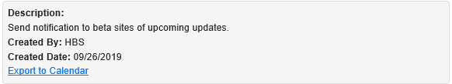

* + - **Color-Coded Status:** Each Task bears a color-coded Status icon, which changes when the Task’s status changes.
      * **Pending:** This  status means the Task has not been completed, but is also not yet past its due date.
        + This is the initial status for each Task when it’s created.
      * **Overdue:** This  status means the Task has not been completed and is past its due date.
      * **Completed:** This  status means the Task is done.
        + You can mark a Pending or Overdue Task as Completed by **clicking** the icon. You can also revert the Task’s status back to Pending or Overdue by clicking it a second time.
    - **List Sections:** The Task list is divided into two sections:
      * **Pending Tasks:** All Tasks that are not marked Complete appear in this section at the top of the screen.
      * **Completed Tasks:** All Tasks marked Complete appear in this lower section.
    - **Expand/Hide All:** Use this option to expand or hide the extra information on **all** Task entries.
    - **Filter Tasks:** If you only want to see Tasks with specific information, enter that data in this field to filter the Task List to show only matching entries.
  + **Add Task:** Click the  button to add a new Task. The tile will switch to show the following:

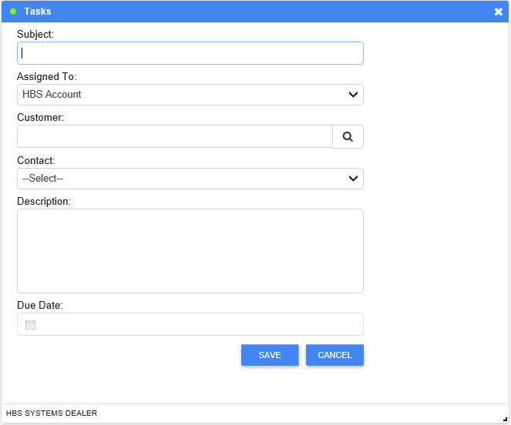

* + - **Subject:** Enter the Task subject here. This field is **required**.
    - **Assigned To:** Select a user here to assign them the Task. This field is **required** and **defaults** to the current user (users can assign Tasks to themselves).
    - **Customer:** If the Task relates to a particular customer, enter the customer number here.
      * If you don’t know the customer’s full number, you can use the Search feature in this field to look it up. Enter all or part of the customer’s name, or any portion of their number you may know, and click “Search” to look up any matching results. Click on the desired result to populate the field with the customer number.
    - **Contact:** If needed, you can use this field to specify a contact for the customer. Select an existing contact from the drop-down menu.
    - **Description:** Enter the Task description here. This field is **required**.
    - **Due Date:** Enter the Task’s due date here or select it from the calendar. This field is **required**.
    - **Save:** Click this button to save the information and create the Task. The tile screen will switch back to the Task List, and the new Task will appear on the Assigned view.
      * The Task will also appear on the My Tasks view if the user self-assigned the Task.
    - **Cancel:** Click this button to return to the Task List without saving the information or creating the new Task.
  + **Edit Task:** To edit a specific Task, click the  icon in its entry. This icon will only appear if the current user **created the Task** or is a **system administrator**. The tile will switch to the following screen:

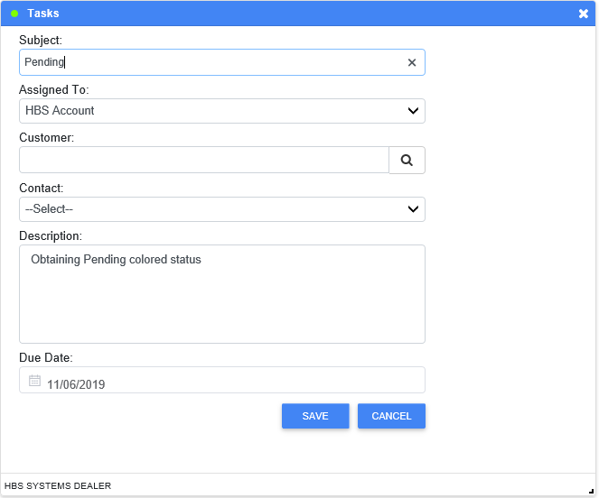

Edit the information as desired, then click **Save** to update the Task’s list entry.

* + **Delete Task:** To delete a Task, click the  icon in its entry. This icon will only appear if the current user **created the Task** or is a **system administrator**. You will receive a warning asking, “Are you sure you want to delete this Task?” Click **Ok** to delete the Task.
  + **Print Tasks:** If you want to print the current Task List view (My Tasks or Assigned), click the  button to generate a PDF report listing all Tasks contained in that view.

**Tasks Totals:**

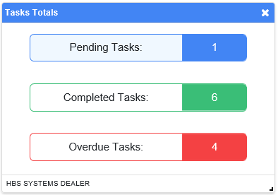

* **Data Set:** View totals of your assigned Tasks.
* **Data Source:** All Tasks assigned to the current user in the Tasks ActiveTile.

**Vision Data Refresh:**

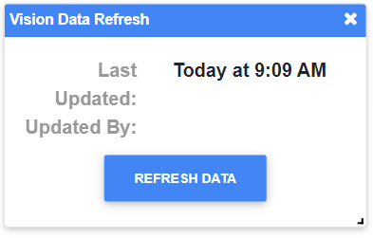

* **Data Set:** Shows the last time your Vision reports were updated and by what user.
* **Data Source:** Vision reports. **NOTE:** Only Vision-enabled dealers can make use of this widget; otherwise it will just show “Loading” if you add it to your Desktop.
* **Features:**
  + **Refresh Data:** Click this button to manually run your Vision data extract. You will only be able to do this once per 30 minutes. **NOTE:** The system automatically performs a Vision data extract once every morning.